MOBILE DETAILING PLATFORMS
Competitive Analysis, Infrastructure Gaps & Customer Feedback
US Market | Founder Research Brief | March 2026

Executive Summary
The US mobile detailing market generates $2.6–3.1 billion annually, growing at 11%+ CAGR, yet remains extraordinarily fragmented — no single platform holds more than 5% market share. The best-funded incumbent, Spiffy ($90.8M raised), is pivoting away from consumer services toward dealer SaaS, creating a significant vacuum in the consumer marketplace segment. Every major platform suffers from the same structural weaknesses: quality inconsistency, broken supply-side economics, and technology that lags a decade behind analogous on-demand verticals.
This report analyzes the full competitive landscape, aggregated customer and detailer feedback, six critical infrastructure gaps, and a phased go-to-market framework for a tech-first new entrant.
Key Findings: No dominant consumer marketplace exists. Quality inconsistency is the #1 complaint (34% of reviews). Spiffy's franchise lawsuits and B2B pivot create a window. App-based bookings are growing at 24.96% CAGR — the highest of any segment. The winning formula requires supply-side tools + B2B fleet anchors + Uber-quality consumer UX, in that order.

1. Market Size & Growth
The US mobile car wash and detailing market is one of the most rapidly digitizing service verticals, driven by post-pandemic consumer preference for at-home convenience, rising vehicle ownership, and the shift from manual to app-based booking. Multiple research sources converge on the following market parameters:
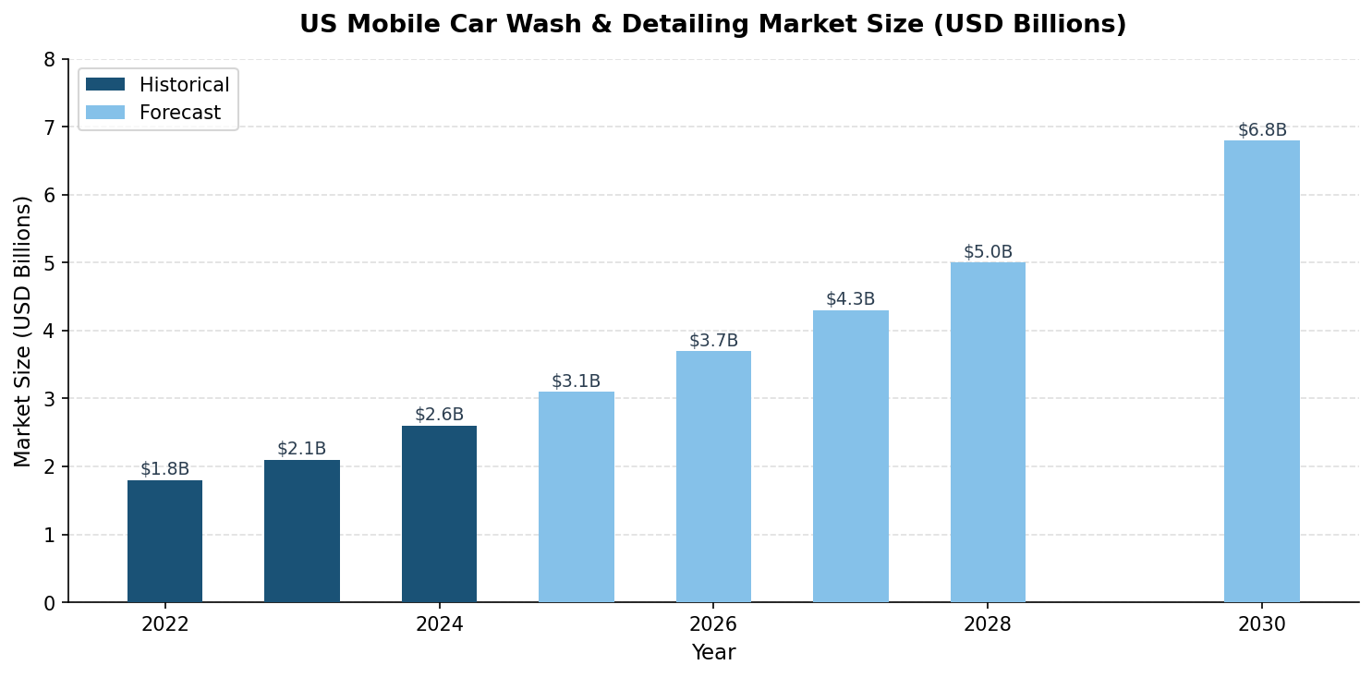
Figure 1: US Mobile Car Wash & Detailing Market Size (USD Billions) — Historical and Forecast
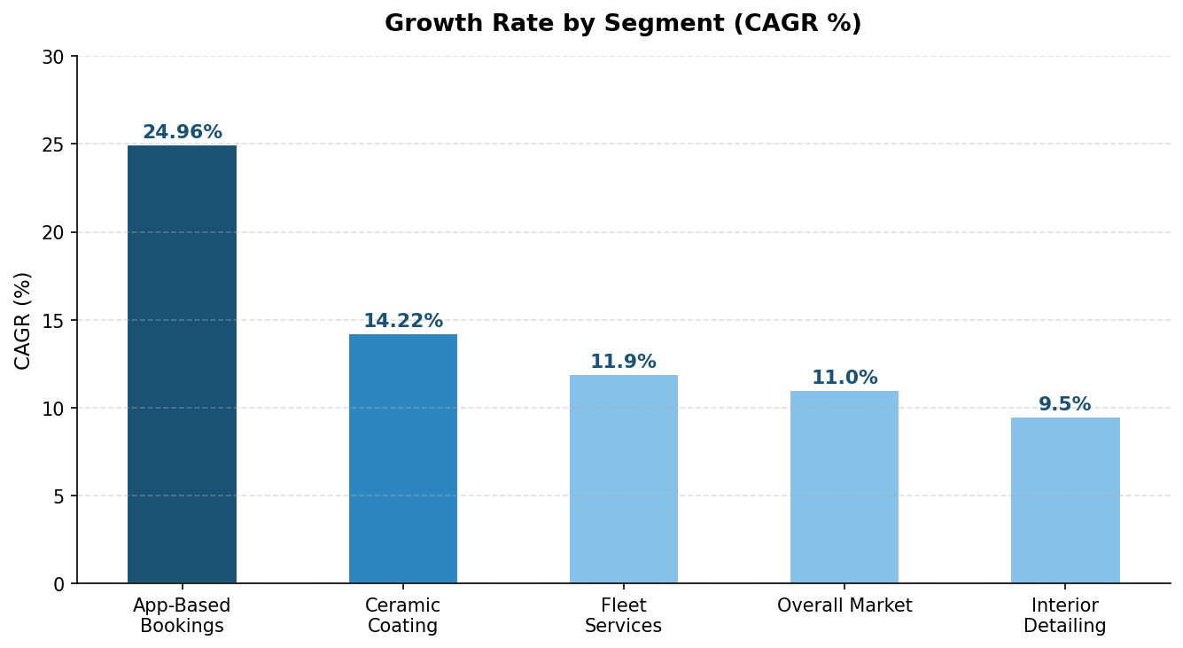
Figure 2: CAGR by Market Segment — App-based bookings lead at 24.96% CAGR
Metric | Value | Source
Market Size (2024) | $2.6–3.1 Billion | Grand View Research, Mordor Intelligence
CAGR (Overall) | ~11% | Multiple sources
App-Based Bookings CAGR | 24.96% | Future Market Insights
Ceramic Coating CAGR | 14.22% | Global Growth Insights
Fleet Services CAGR | 11.9% | Grand View Research
US Drivers Using Pro Car Wash | 79% | MMCG Invest (2025)
Increase in Mobile Adoption (post-COVID) | +34% | AP Formulators (2025)
Largest Player Market Share | <5% (Spiffy) | IBISWorld 2026

2. Competitive Landscape
The mobile detailing platform space is defined by Spiffy's dominance in funding and revenue, a string of marketplace failures, and a handful of scrappy survivors operating at modest scale. No single company has achieved the dominant marketplace position that DoorDash (55% share) or even GreenPal (lawn care) has in analogous verticals.
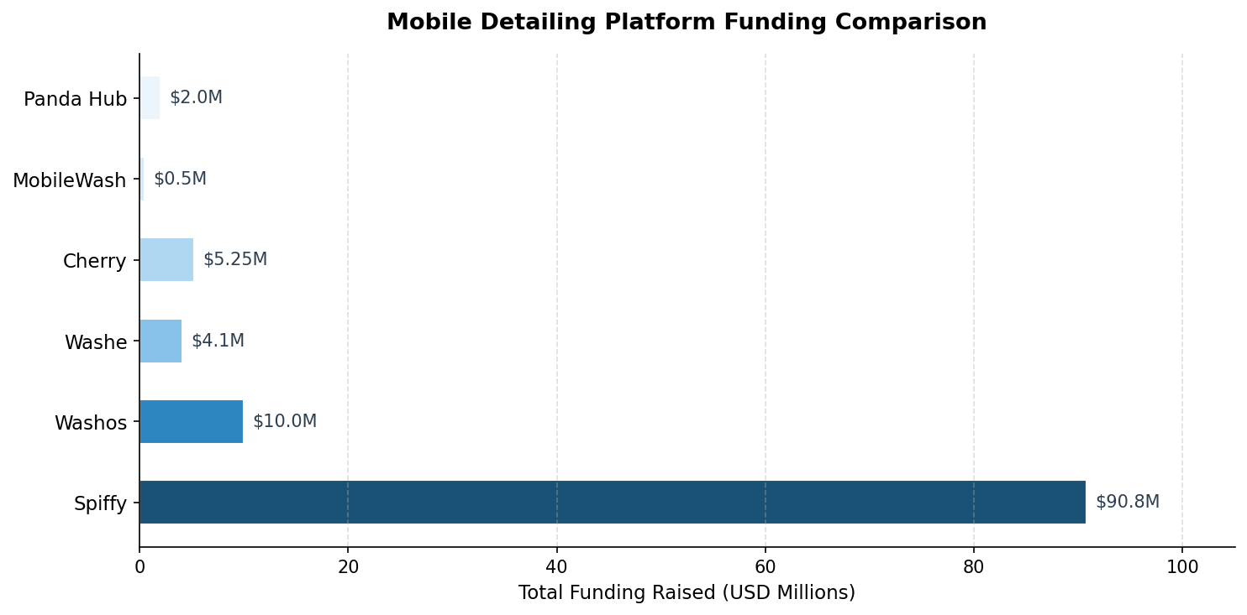
Figure 3: Total Funding Raised by Mobile Detailing Platform (USD Millions)
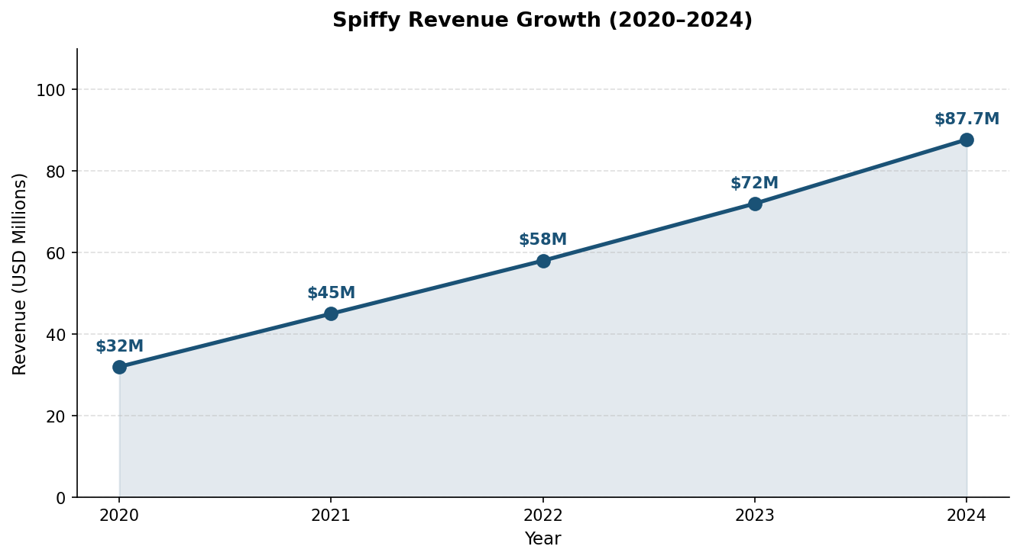
Figure 4: Spiffy Revenue Growth 2020–2024 (USD Millions)

2.1 Platform Comparison Table
Platform | Business Model | Funding | Revenue | Markets | Status
Spiffy | W2 + Franchise + SaaS | $90.8M | $87.7M (2024) | 45+ metros | Active (lawsuits)
Washos | 1099 Marketplace | ~$10M | N/A | CA, TX, FL | Active
MobileWash | 1099 Marketplace | Self-funded | N/A | SoCal primary | Active (IC lawsuit)
Panda Hub | 1099 Marketplace | Undisclosed | N/A | 100+ cities | Active, growing
RideKleen/Pivet | W2 (Cox Automotive) | Corporate | N/A | 10 markets | Active
DetailXPerts | Steam Franchise | Self-funded | N/A | Multiple US | Active
Washe | 1099 Marketplace | $4.1M | N/A | FL, NJ, GA, CA | Dead
Cherry | 1099 Marketplace | $5.25M | N/A | SF Bay Area | Dead
Note: Status colors: Green = Active, Orange = Active with legal/operational concerns, Red = Out of business. Sources: Tracxn, Crunchbase, PitchBook, GetLatka, PR Newswire.

2.2 Competitor Deep Dives
Spiffy (Get Spiffy, Inc.)
Headquarters: Durham, NC | Founded: 2014
Funding: $90.8M across 8 rounds (Seed → Series C, Feb 2023)
2024 Revenue: $87.7M with 410 enterprise customers
Model: W2 employees, 300+ branded vans, 500+ technicians, 45+ markets, 4M+ services completed
Spiffy is the category's best-funded and highest-revenue player. It operates as a vertically integrated service company: proprietary van upfits manufactured at an 8,000 sq ft facility, connected diagnostic devices (Easy Tread™, Easy Flow™), and an expanding menu including oil changes, tire service, and brakes. However, Spiffy's strategic trajectory has shifted dramatically — the company now positions as "The Mobile Service Operating System for Dealers," a B2B SaaS play for automotive dealerships. Multiple franchise lawsuits filed in May 2025 allege fraud, RICO violations, and inflated profitability projections, creating significant brand risk.
Washos
Headquarters: Glendale, CA | Model: 1099 Marketplace
Funding: ~$10M | Coverage: CA, TX, FL
Washos remains the most active consumer marketplace. It claims a 5% detailer acceptance rate and 100,000+ bookings, with the ability to request preferred detailers. However, App Store reviews document repeated issues with technician quality and damage resolution processes.
MobileWash
Headquarters: Los Angeles, CA | Model: Self-funded 1099 Marketplace
The dominant app in Southern California with a large installer base. Faces a California Labor Commissioner lawsuit over contractor misclassification. Persistent user complaints about broken GPS tracking and inaccurate ETAs. Piloted AI routing optimization in 2024 that improved van productivity from 12 to 16 jobs/day (+33%).
Panda Hub
Headquarters: Houston, TX | Founded: 2020
Most promising newer entrant — operating in 100+ US and Canadian cities with IDA-certified detailers, vehicle-specific dynamic pricing, and strong city-by-city SEO. Less VC-funded but operationally sound.
Casualties & Lessons
- Cherry ($5.25M from Founders Fund, Shasta Ventures): Shut down December 2012. Team acqui-hired by Lyft. Low frequency + thin margins on basic washes killed the model.
- Washe ($4.1M raised): Confirmed out of business. Florida/NJ/GA/CA markets.
- Squeegy & Wype: Both dark. Same failure pattern: 1099 quality variance + venture expectations misaligned with service economics.
The failure pattern is consistent: low transaction frequency (every 3–4 months vs. daily food delivery), quality control breakdown with 1099 contractors, and venture return expectations misaligned with service business unit economics.

3. Infrastructure Gaps
The mobile detailing industry's technology and operational infrastructure lags analogous on-demand verticals by roughly a decade. Six gaps stand out as both severe and addressable by a well-capitalized new entrant.

3.1 Gap Analysis Table
Gap Area | Priority | Current State | What's Needed
Dynamic Pricing | HIGH | None | Time/demand-based pricing; surge model; vehicle-condition pricing
Route Optimization | HIGH | Basic (MobileWash pilot) | Purpose-built for 30–120 min service windows; supply-capacity routing
AI Quality Verification | HIGH | None | Before/after photo scoring; automated quality benchmarking; warranty triggers
Fleet Management API | MEDIUM | None | API integrations with ARI, Element, LeasePlan; automated scheduling triggers
Embedded Insurance | MEDIUM | None | Garage-keepers liability; on-demand worker coverage; per-job policies
Hybrid Labor Model | HIGH | Binary W2/1099 | Quality-gated tier system with training/certification paths

3.2 Gap Detail: Dynamic Pricing
No platform implements demand-based, time-slot, or surge pricing. Detailing services are priced with static packages despite enormous variance in actual cost drivers: vehicle size, condition, distance, demand density, time of day, and weather. MobileWash's AI routing pilot demonstrated that even basic algorithmic operations can improve van productivity by 33% (12 to 16 jobs/day). Dynamic pricing is perhaps the single highest-impact technology investment a new entrant could make.

3.3 Gap Detail: AI Quality Verification
Before/after photo capture exists in tools like Mobile Tech RX, Fieldd, and ScheduleDrop, but no platform performs automated quality scoring. No standardized quality benchmark exists across the industry. No platform offers warranty-backed service guarantees tied to documented quality evidence. This gap directly causes the #1 customer complaint — quality inconsistency — and is solvable with modern computer vision.

3.4 Gap Detail: Fleet Management Integration
Despite fleet services being the fastest-growing segment (11.9% CAGR), there is no standard API connecting fleet management platforms (ARI, Element, Enterprise Fleet, LeasePlan) to detailing providers. No automated triggers exist to schedule detailing when a vehicle hits a mileage threshold or utilization event. Only Spiffy and RideKleen/Pivet offer fleet-grade operations, both as vertically integrated services rather than open platforms.

3.5 Gap Detail: Hybrid Labor Model
Spiffy chose W2 (higher quality, higher cost). Every marketplace chose 1099 (lower cost, quality variance, legal exposure). No platform has built a quality-gated contractor tier system — where vetted, certified contractors earn access to premium jobs while lower-tier contractors handle basic washes. This technology-enabled hybrid model could solve quality-at-scale while maintaining marketplace economics.

4. Customer Feedback Analysis
Customer feedback was aggregated from the App Store, Google Play, Yelp, Glassdoor, BBB, Reddit, and third-party review sites for Spiffy, Washos, MobileWash, and Panda Hub. The pattern is consistent: customers love the concept but are frequently disappointed by execution.
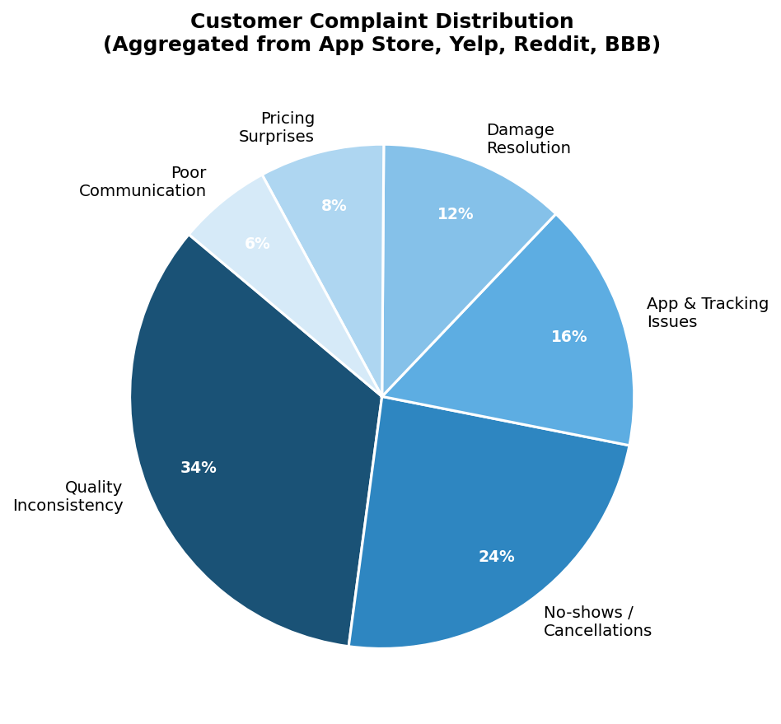
Figure 5: Customer Complaint Distribution (Aggregated from App Store, Yelp, Reddit, BBB)

4.1 Comprehensive Feedback Table
Theme | Sentiment | Detail
Convenience & time-saving | Positive | Service at home/work eliminates trip to physical location
Quality when matched well | Positive | Best technicians deliver transformative results; loyal repeat users
Easy app booking | Positive | One-tap scheduling praised across Spiffy, Washos, MobileWash
Same-detailer requests | Positive | Washos allows preferred detailer selection; high satisfaction
Quality inconsistency | Negative | Most-cited complaint (34%); "found locally from Craigslist" technicians
No-shows & cancellations | Negative | 24% of complaints; scheduling days ahead only to have providers bail
Broken GPS / tracking | Negative | MobileWash GPS "stays in one place"; ETAs chronically wrong
Damage resolution | Negative | Washos caps claims at $5K with 48-hr window; platforms ghost after photos
Pricing surprises | Negative | Add-on fees not shown upfront; tips deducted (Spiffy)
No interior-only option | Unmet Need | Customers who hand-wash exteriors want interior-only service
Real-time tracking | Unmet Need | Uber-quality arrival tracking expected; no platform delivers it
Subscription plans | Unmet Need | Pause/resume monthly plans with loyalty rewards

4.2 Supply-Side (Detailer) Feedback
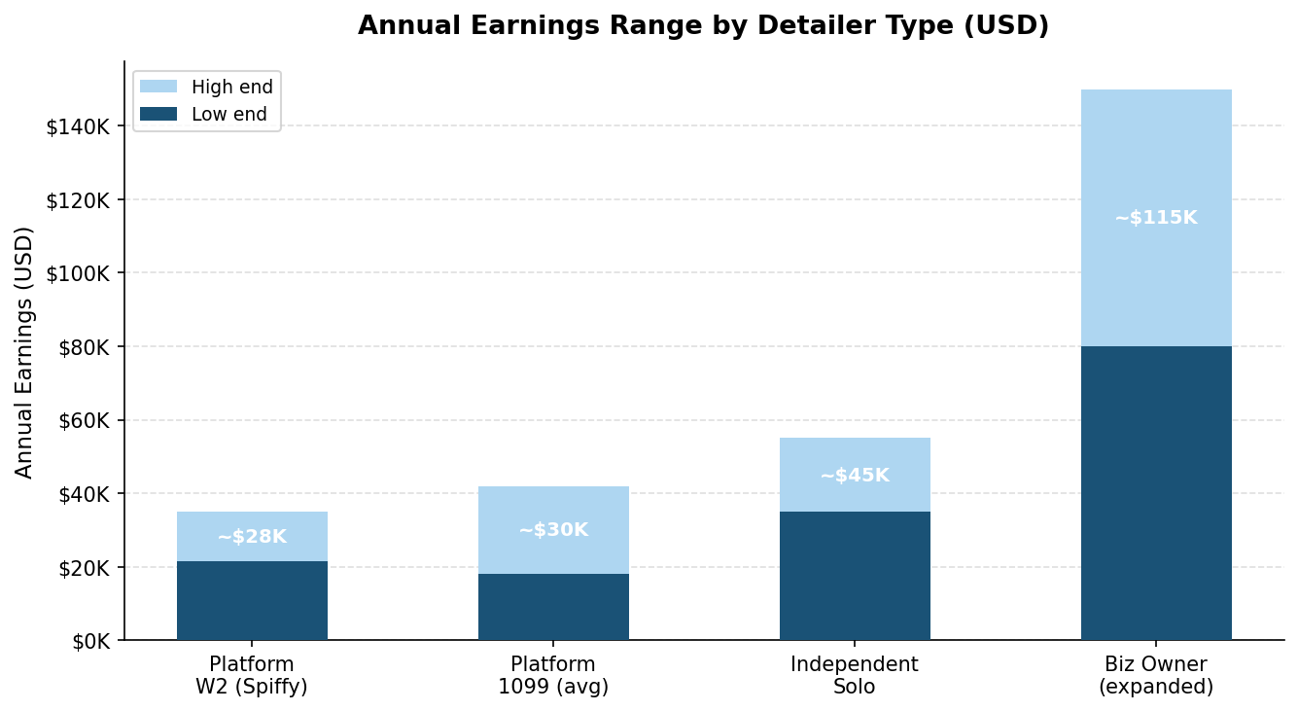
Figure 6: Annual Earnings Range by Detailer Type (USD)
Spiffy's Glassdoor profile (3.2/5 stars, 37% recommend) reveals severe supply-side problems. Technicians report working 12–14 hour days, 6 days/week (100 hours per biweekly period). Equipment is described as "always broken, not maintained." The company allegedly stacks services back to back and then expects workers to explain lateness to customers.
- One review describes a 20% deduction from app-based tips by the platform.
- Workers report no PPE provided for biohazard cleanup (vomit, feces, blood).
- Recurring Glassdoor theme: "Work them till they break, then replace them."
- For 1099 platforms: contractors must supply their own equipped van ($5K–$15K startup cost), receive no training or equipment support, and face inconsistent job volume.
The earnings gap between platform work (~$21K–$35K/year) and independent operation (~$50K–$80K+/year) explains why the best detailers avoid platforms entirely — creating the bimodal supply pool that causes quality inconsistency.

5. Go-to-Market Playbook for a New Entrant
A well-funded platform builder would need to sequence four phases correctly, learning from both the successes and failures documented in this report. The key insight from Spiffy's trajectory and the marketplace graveyard: you cannot start with a consumer marketplace. You must solve supply quality before launching demand.

5.1 Phase Roadmap
Phase | Timeline | Focus | Capital | Key Actions
Phase 1 | Months 1–6 | Supply-Side SaaS | $500K–$2M Seed | Build free tools for independent detailers: scheduling, CRM, route optimization, invoicing. Recruit 20–30 credentialed detailers in one metro. Build portable detailer credential system.
Phase 2 | Months 3–9 | B2B Fleet Anchor | $500K–$2M Seed | Secure 3–5 fleet contracts (rental agencies, rideshare, dealerships) to guarantee baseline utilization. Validates unit economics before consumer launch.
Phase 3 | Months 6–12 | Consumer Marketplace | $5–15M Series A | Launch consumer-facing app with Uber-quality tracking, dynamic pricing, detailer profiles, before/after AI verification, interior-only options, subscription plans.
Phase 4 | Months 12–24+ | Geo Expansion | $20–50M Series B | Replicate in affluent Sun Belt suburbs. Prioritize year-round markets, high WTP zip codes, low existing competition. DoorDash suburban playbook.

5.2 Three Critical Strategic Choices
1. Hybrid Labor Model
Use a quality-gated tier system. Certified, IDA-trained detailers earn access to premium, high-margin jobs (ceramic coating $500–$2,000, PPF installation, fleet reconditioning). Standard-tier contractors handle basic exterior washes. Training modules, skill assessments, and verified service history create the differentiation. This solves quality-at-scale without the full cost burden of a W2 workforce.
2. High-Margin Service Specialization
Ceramic coating ($500–$2,000 per job, 14.22% CAGR), paint protection film, and EV-specific detailing packages justify mobile travel costs and dramatically improve unit economics vs. competing on $29 basic washes. Average order values of $200–$400 for premium packages change the marketplace math entirely.
3. AI-Powered Operations from Day One
Dynamic pricing based on demand, vehicle condition, and weather. Route optimization purpose-built for 30–120 minute service windows. Before/after photo quality scoring. Even MobileWash's basic routing pilot achieved 33% productivity gains. A purpose-built system could realistically achieve 40–50% gains, making the economics of W2 or hybrid employment viable.

5.3 Capital Requirements
Round | Amount | Milestone | Key Uses
Seed | $500K–$2M | 1 metro, 20–30 detailers, MVP | Supply-side SaaS tools, detailer credential system, 3–5 fleet contracts
Series A | $5–15M | 5–10 metros, consumer app | Consumer marketplace, AI routing, quality verification, brand
Series B | $20–50M | National expansion | Geo rollout, embedded insurance, fleet API integrations, M&A

6. Conclusion
The mobile detailing platform space presents a rare combination: a multi-billion-dollar market with proven and growing consumer demand, zero dominant tech-first marketplace, an incumbent leader pivoting away from consumer services, and infrastructure gaps that modern technology can decisively address.
The failures of Cherry, Washe, Squeegy, and Wype demonstrate that the naive "Uber for car wash" approach doesn't work. The winning formula requires supply-side tools that attract and credential quality detailers, B2B fleet contracts that provide baseline utilization to solve the chicken-and-egg problem, and consumer technology that meets post-Uber expectations for tracking, pricing, and quality verification.
The founder who sequences these correctly — starting in one affluent suburban metro, specializing in high-margin services, and treating detailers as platform partners rather than interchangeable labor — has a genuine shot at building what Spiffy could have been before it pivoted to become a dealer software company.

Sources & References
All data, customer reviews, funding figures, and market statistics in this report are sourced from the references listed below. Research conducted March 2026.
# | Source | Title / Description | Domain
1 | Tracxn | Spiffy – 2026 Company Profile, Funding & Competitors | tracxn.com
2 | Business Wire | Spiffy Announces $30M Series C (Feb 2023) | businesswire.com
3 | Edison Partners | Spiffy Raises $32M Extended Series B | edisonpartners.com
4 | GetLatka | How Spiffy Hit $87.7M Revenue and 410 Customers in 2024 | getlatka.com
5 | PR Newswire | Get Spiffy Faces Multiple Lawsuits Alleging Franchise Deception (2025) | prnewswire.com
6 | App Store (Apple) | Washos: Mobile Car Detailing – Customer Reviews | apps.apple.com
7 | App Store (Apple) | MobileWash Car Wash On-Demand – Customer Reviews | apps.apple.com
8 | App Store (Apple) | Spiffy On-Demand Car Care – Customer Reviews | apps.apple.com
9 | Yelp | SPIFFY – ON-DEMAND CAR CARE, Morrisville NC (95 Reviews) | yelp.com
10 | Yelp | SPIFFY – Charlotte NC (23 Reviews) | yelp.com
11 | Glassdoor | Working at Get Spiffy – Employee Reviews | glassdoor.com
12 | Glassdoor | Get Spiffy – Mobile Technician Review (Car Wash/Detailing) | glassdoor.com
13 | Scaled and Failed (Substack) | Issue #22 – Spiffy and Cherry | scaledandfailed.substack.com
14 | PYMNTS.com | Uber of X: Spiffy Is the Uber of Car Washing | pymnts.com
15 | Grand View Research | Mobile Car Wash Service Market Size & Share Report, 2030 | grandviewresearch.com
16 | Mordor Intelligence | Car Detailing Services Market Size, Share, 2025–2030 Outlook | mordorintelligence.com
17 | Future Market Insights | Mobile Car Wash & Detailing Market Size & Forecast 2025–2035 | futuremarketinsights.com
18 | MMCG Invest | U.S. Car Wash & Auto Detailing Industry Overview 2025 | mmcginvest.com
19 | IBISWorld | Car Wash & Auto Detailing in the US Industry Analysis, 2026 | ibisworld.com
20 | ZipRecruiter | Mobile Detailer Salary: Hourly Rate USA | ziprecruiter.com
21 | Jobber Academy | How Much Do Auto Detailers Make? Salaries and Income Factors | getjobber.com
22 | Crunchbase | Washos – Company Profile & Funding | crunchbase.com
23 | PitchBook | Washe 2025 Company Profile: Valuation, Funding & Investors | pitchbook.com
24 | on-demand-app.com | Washos Mobile Car Wash Business Model Deep Dive | on-demand-app.com
25 | ION Analytics | New Entrants Could Shift Car Wash M&A Back Into Drive | ionanalytics.com
26 | TheStreet | Huge National Car Wash Chain (Zips) Files Chapter 11 Bankruptcy | thestreet.com
27 | Carwash Country | My Honest Review of Get Spiffy Mobile Car Wash & Detailing | carwashcountry.com
28 | Mobile Tech RX | Detailing Business Software That Increases Revenue & Efficiency | mobiletechrx.com
29 | Global Growth Insights | Car Detailing Service Market Size & Share [2033] | globalgrowthinsights.com
30 | AP Formulators | Top Car Wash Trends That Shaped 2024 Going Into 2025 | apformulators.com
* Market size figures sourced from multiple independent research firms; ranges reflect variance across methodologies. Revenue and funding data from Tracxn, Crunchbase, PitchBook, and GetLatka as of March 2026. Customer sentiment analysis based on publicly available reviews only.

